Book a meal and get a glass of Cocktail juice only at Campus Cafe inn

Student’s Name
Institutional Affiliation
Course Name and Number
Instructor’s Name
Submission Date
Have you ever thought of taking the meals of your taste with a glass of cold cocktail? Campus café inn offers the best meals and exceptional services from their customer-centered waiters and waitresses in the University diaspora and within the city.
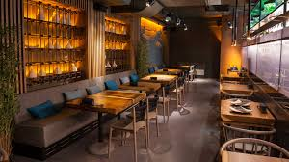
Enjoy an ice-cold Cocktail juice as you wait for your order to be served. The campus café inn is conducive to all with 360 maximum security, tasty foods, free wifi, and Vip cabins availability. A wide range of all sorts of foodstuffs is available. The café is in operation at a 24 hours system. Are you wondering where to spend your night after visiting the Campus café inn at night? Your dream apartments are available with well-furnished furniture, hot water showers, and free supper and breakfast provided. Get yourself a lunch compo and book for a room with free dinner and breakfast now. Besides, Incase one gets lunch and dinner bookings, for every 30 successful constructive bookings of both lunch and dinner, the 31st booking free meals are offered. It is your time now to get into the race now and win yourself a free meal. Never say tomorrow, which never comes.
Mission and Vission of Campus Café inn
At Campus café inn, customer loyalty is their primary objective, where they work towards achieving their mission and vision.

The mission statement:
Their mission states that; to be the best café chain by offering world-class meals at affordable prices, customer-friendly.
The vision statement:
The vision states that; to be the only office for dialogue for quality services and meals in the city.
Types of foods offered
Some of the common foods available include in our café includes;
Rice dishes
The standard rice dishes available include; Charleston red rice, Calas, Glorified Rice, Chicken bog, Hoppin' John, Gumbo, Jambalaya, Hawaiian haystack, Spanish Rice, Rice and gravy, and Shrimp Creole rice (Wu & Haytowitz, 2016).
Hawaiian haystack rice (Wu & Haytowitz, 2016)
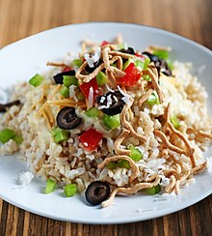
Sandwiches
The major types of sandwiches available in our café are Club sandwich, Open-faced sandwich, submarine sandwich, Bagel toast sandwich, and Pocket sandwich.
A Bagel toast sandwich (McConahy, 2014)
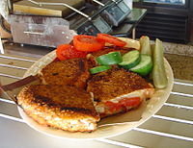

Sausages
A variety of sausages are available such as Bologna sausage, Chaudin, Hot dogs with various toppings, Half-smoke, Italian hot dog, Breakfast sausage, Hot dog, Polish Boy, Lebanon bologna, Goetta, and Maxwell Street Polish sausage.
Breakfast sausage (McConahy, 2014)
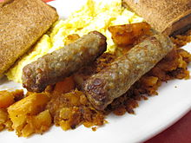

Cool your nervous about where to get your quality, visit us at your convenient time, and enjoy our services and relaxed meals. On Fridays, we give offers and free dinners for the first 100 people who visit our place after 7 pm. Welcome and have the fun of the tasty meals. Chances come once make use of the opportunity, our dear esteemed customer. Bookings of the guest houses can also be made online on our website, accessed through the link https://www.campuscafeinn.com. There are free meal coupons on Friday lunch hour to launch to welcome the first years in the University. The coupons are for the first 100 people who will attend the café immediately after 1.00 pm. come and enjoy yourself.


References

McConahy, K. L., Smiciklas-Wright, H., Mitchell, D. C., & Picciano, M. F. (2014). The portion size of common foods predicts energy intake among preschool-aged children. Journal of the American Dietetic Association, 104(6), 975-979.
Wu, X., Beecher, G. R., Holden, J. M., Haytowitz, D. B., Gebhardt, S. E., & Prior, R. L. (2016). Concentrations of anthocyanins in common foods in the United States and estimation of average consumption. Journal of agricultural and food chemistry, 54(11), 4069-4075.

